FIAT SPECIFICATIONS – v 1
FIAT SPECIFICATIONS – v 1 1
Signiture 2
Overview 2
Modular Programming 5
SQL Friendly 5
Control 5
Get in All Data 6
Export Data to FIA Master Template 6
Print daily residuals 7
Test iPas Connection 7
Prepare CDS for FIA template 8
Clear All tables 8
Breakdown 8
StaticChecks 8
Calculation 9
Prepare Table 9
B1Export 10
Get aggregated Bone FIA results 10
Get unaggregated Bone FIA results 11
Fix CDS Names and ISINs 11
Prepare CDS Mapping 11
B1Returns 11
DTS 12
BbergData 12
Get ISINs 13
Insert Bloomberg formulas 13
Convert the data to values only 13
Commit this data to iPas 13
Clear Data 14
DMO Instrument Download 14
iPasStaticData 15
Get FIA Static Data 15
Clear this Sheet 15
ISIN_StaticData 17
Get Static Data New Instruments 17
Get Static Data 18
Insert Checks 18
Clear this table 18
Save to iPas 18
Convert To values 19
ISIN_Classification 19
Get ISIN and B-One Levels New Instruments 20
Get ISIN and B-One levels 20
Insert Classification Checks 20
Store Levels to iPas 20
Clear this table 21
ConfigTables 21
CDSMapping 21
Reference 21
User ExcelToOracle API description for connection 21
List of the iPas objects used 22
Tables 22
Functions 22
Stored Procedures 22

Signiture

This document was put together by Radek Chramosil, RC69175. It outlines the functionality of the tool that is used to prepare all relevant data for fixed income attribution reports.

Overview

Fiat works with 4 databases – B-One, IRIS Phoenix and iPas. The schema below shows Fiat’s functionality. It only writes to iPas and other Excel files at the moment.
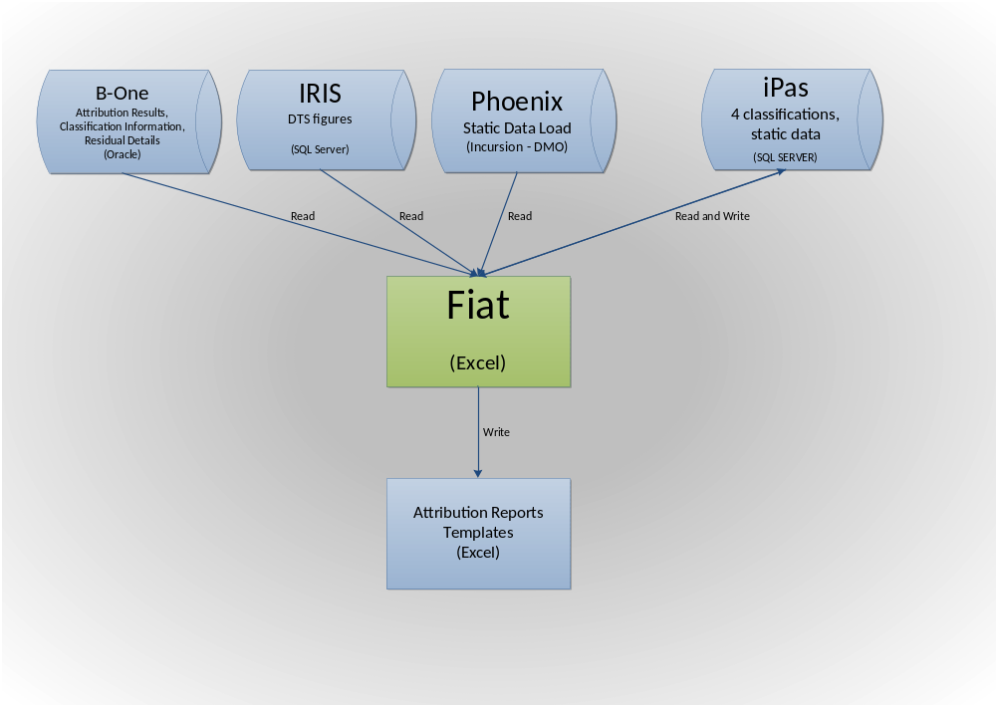

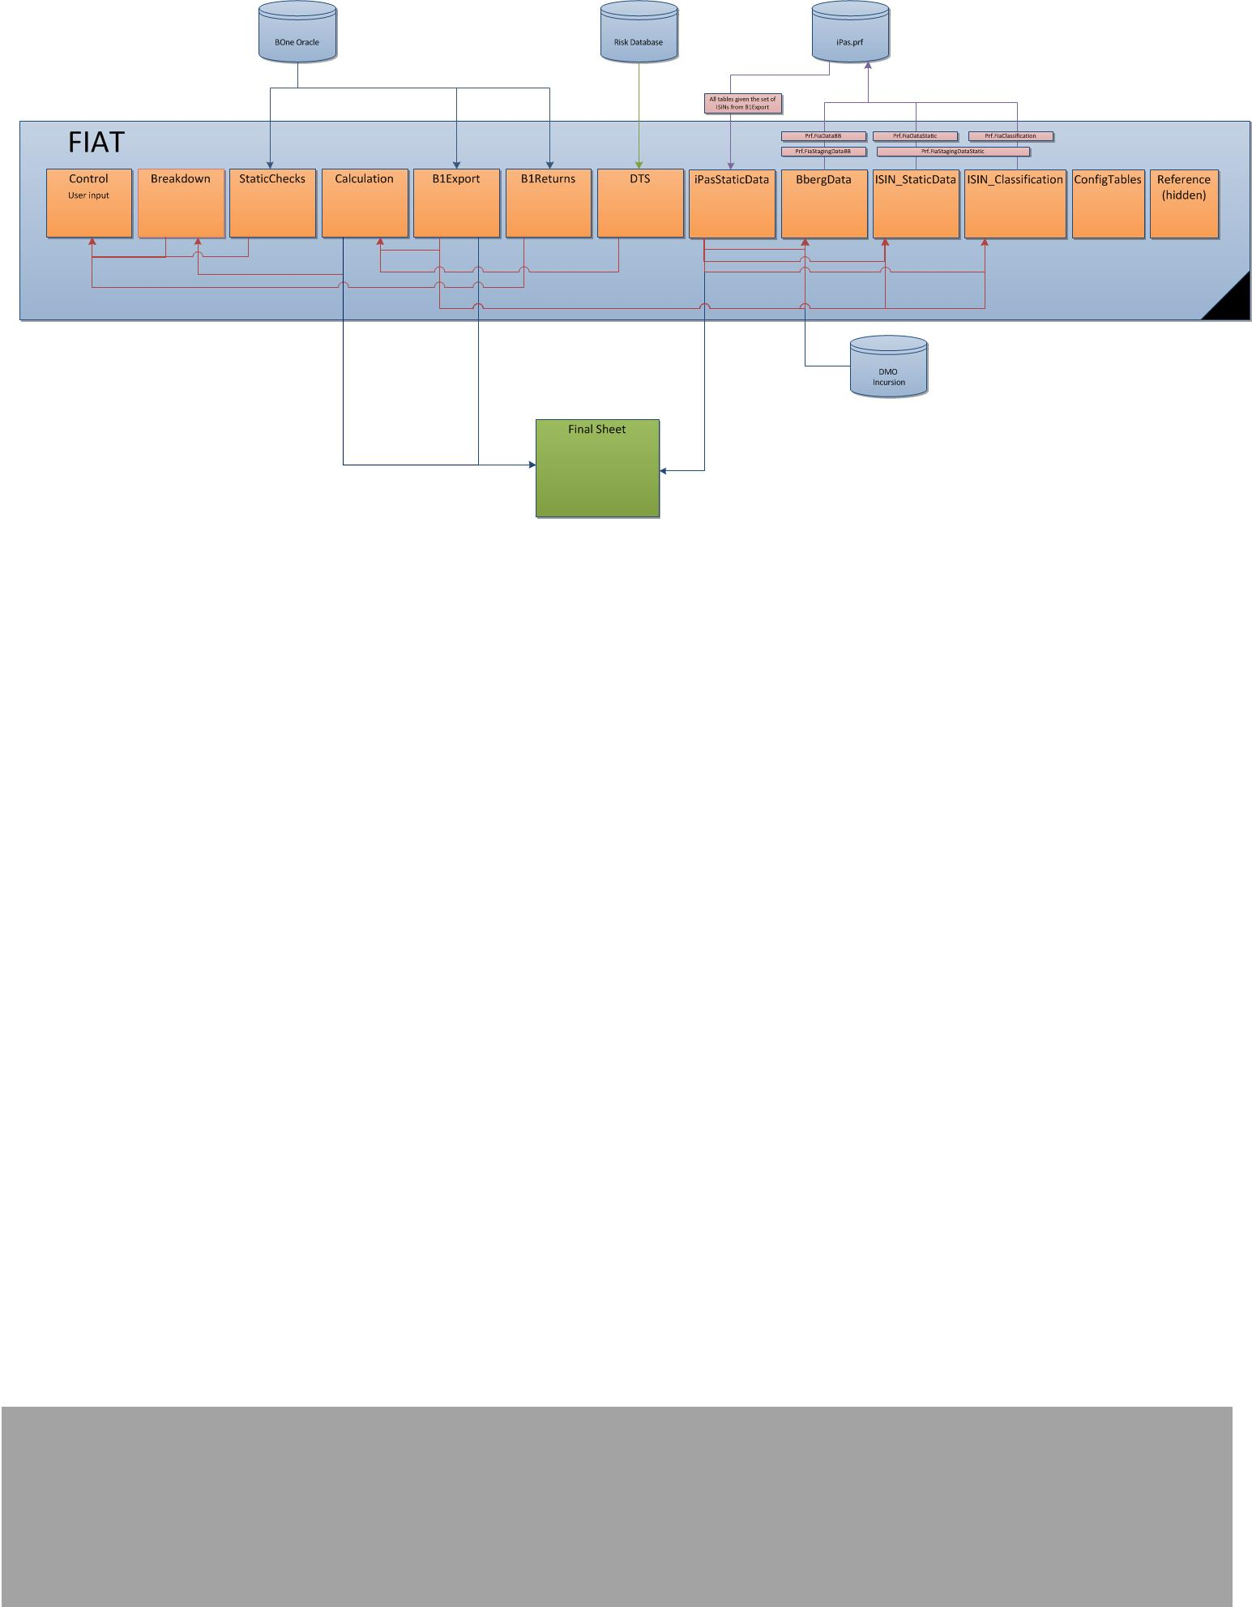

Modular Programming
The sheet has modular programming philosophy. Each sheet has a specific business and programming purpose. The table below shows an overview of the sheets.

Sheet | Purpose | MultipleFunds
Control | All codes can be run from this sheet. User has to select the relevant fund and time period here. | NotAvailable
Breakdown | Show attribution breakdown for each asset type. | NotAvailable
StaticChecks | These are checks for the fund and benchmark settings in B-One | NotAvailable
Calculation | Performs specifica calculations required for the attribution | NotAvailable
B1Export | Collects data from B-One | Available
B1Returns | Collects fund returns from B-One | Available
DTS | Collects DTS figures | NotAvailable
BbergData | Collects data from Bloomberg and commits it to iPas | Available
ISIN_StaticData | Prints available classifications and commits it to iPas | Available
ISIN_Classification | Prints available classifications and commits it to iPas | Available
ConfigTables | Holds tables for calculation sheet | Available
CDSMapping | CREATED IF CDS ARE PRESENT in the FUND, Collects detailed data about CDS from B-One | NotAvailable
Reference | HIDEN - holds a table for control sheet | Available

SQL Friendly
Each sheet is available for SQL queries to be used against the sheet. This means that the first row of each sheet must be used as column headings.

Control
Control sheet is below:
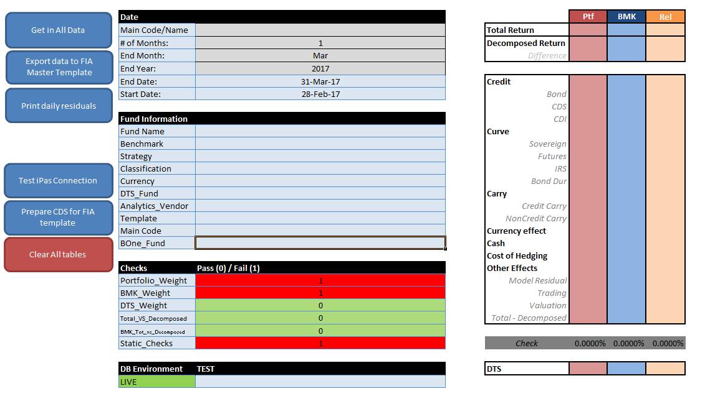

This sheet controls the whole process. The light blue section is for fund details and data information. User picks the fund to do here. The section on the right hand side is the attribution summary for the fund.

Get in All Data
Performs following actions. Look up the actions in the table of content.
- Import the returns for the fund
- Import the DTS data
- Import the attribution data from B-One
- Prepare the FiaT’s attribution calculation
- Imports the static classification data from iPas
- Completes some static checks

Export Data to FIA Master Template
This code relies on the fact that it is possible to treat the workbook’s sheet as Access SQL tables using the Microsoft ActiveX Data Objects reference. The connection is wrapped in the function called ‘executeQuery’ in the module ‘modLocalFunctions’ (see the comments in FiaT). The schema for the query is:

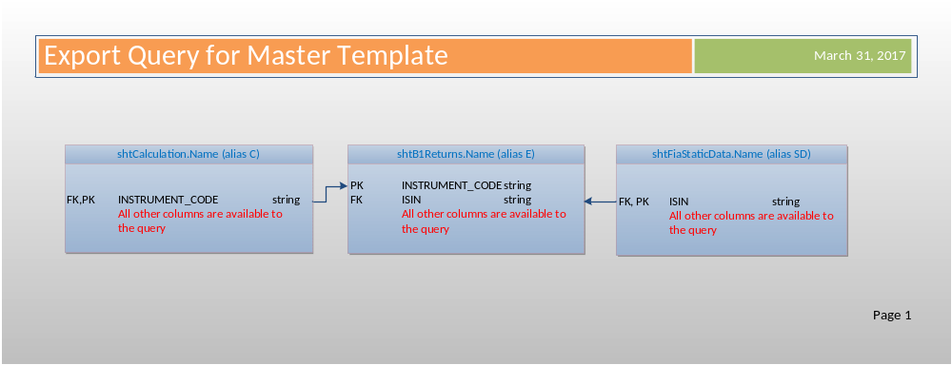
The main idea is that we can any column we wish from the whole workbook.

The subroutine prepares different columns for different templates.

If there are CDS in the portfolio, then there are two of these quires done as the CDS have different foreign keys however the idea is the same.

The query results are copied to the target template or printed onto a new workbook.

Print daily residuals
This functionality was under development at the time of writing this file.

Test iPas Connection
This is for development mainly. It returns the SQL Server environment to which the sheet is connecting to. The environment is set the named range ‘rngDBEnvironment’ as below.

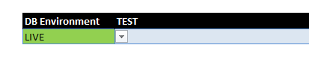

When you run the code, the envirnment is printed here:

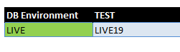

Prepare CDS for FIA template
This print the CDS template query results only. This is used when working with CDS only. See the section ‘Export Data to FIA Master Template’ for references.

Clear All tables
This wipes data from all named tables and selects range A1 on each sheet. It also sets the screen on the same range.

Breakdown
This sheet only summarises the calculation sheet. The summary on the control page is dependent on this. No coding is required to deal with this sheet.
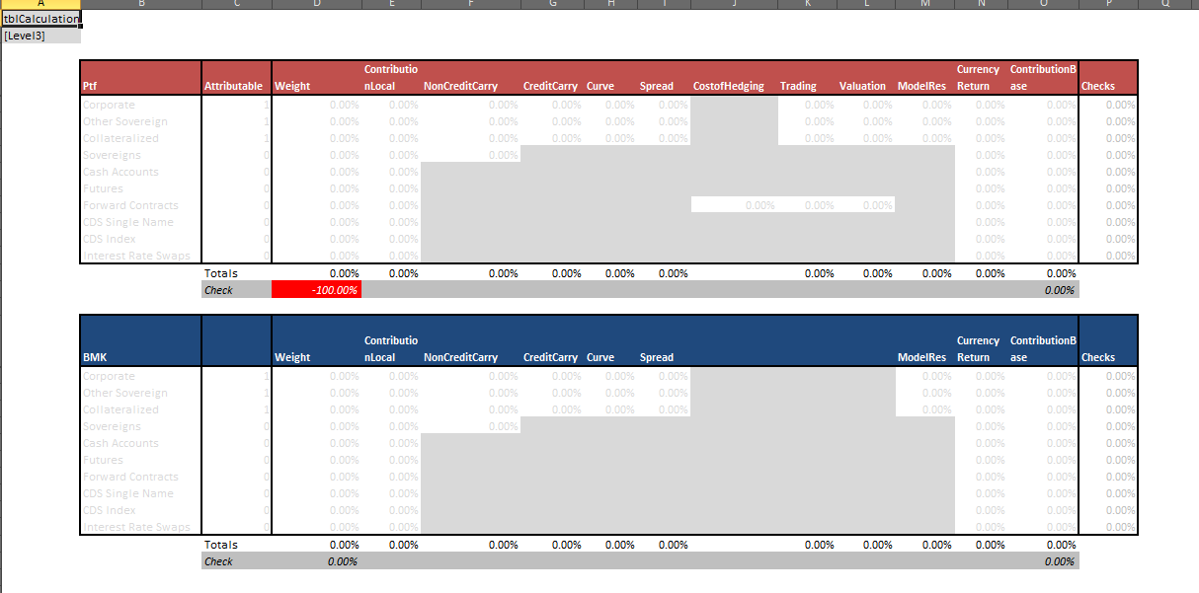

StaticChecks
This sheet collects specific columns from B-One and fills in the below two named tables. The checks are based on value/string equality. Zero is for passing and one for failing so we can perform multiple checks and any one of them has value one, then we know that we have to investigate the whole group. See the formulas to understand more. There are quite simple.

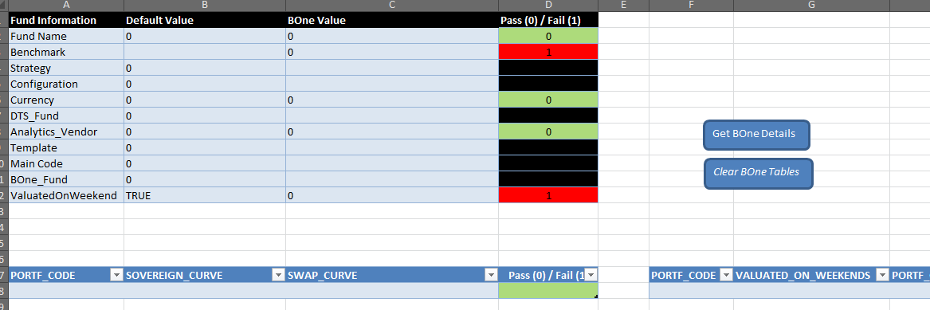

Calculation
The calculation sheet performs the necessary calculation adjustments that are needed to prepare the final report.

Prepare Table
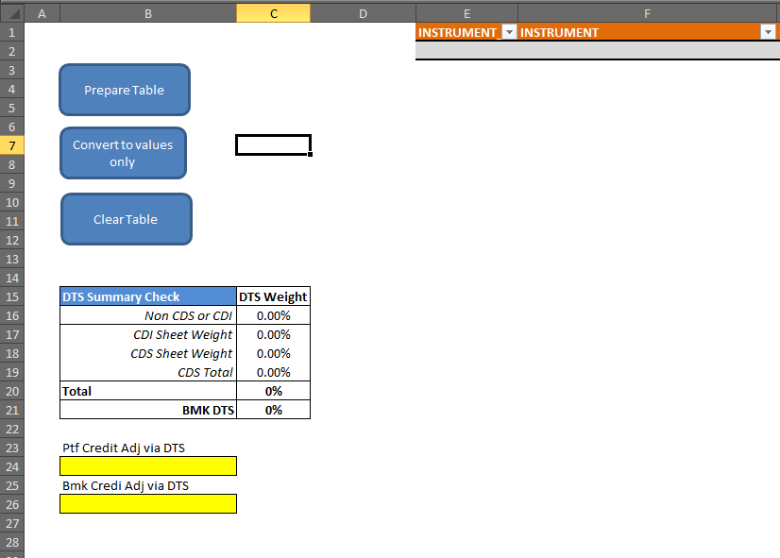
The coding logic here used is that the whole named table is produced based on the formulas that are stored to the VBA module. The lines in this table exactly follow the ordering from the B-One export table (sheet: shtBOneData as below).
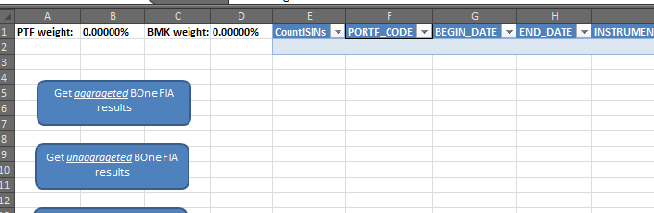

When you run the code ‘Prepare Table’ the code inserts the formulas to the top row and automatically copied to the rest of the column. The number of rows is adusted to the B-One export table size, the are equal in terms of rows.
The formulas are stored to VBA to the user has an option to amend the calculation as he likes but once this code is re-run the changes are not overwritten by the default.
Also, it is important to remember that this sheet is driven by column headings. If the column heading are changed, the VBA code must be adjusted accordingly.
See the section ‘Export Data to FIA Master Template‘ to see how the query works with this sheet. All columns are exportable to the final table.

B1Export
This sheet is the import sheet for attribution results from B-One.

Get aggregated Bone FIA results
This query works by grouping by and summing up the attribution result lines for specific identifiers for specific instrument types. See the below table:

Instrument Type | Unique Indentifier | Field Name in BOne
Bond | ISIN | EXTERNAL_CODE_TYPE_ID are '1000016', '1000017', '1000018', '1000032' - All ISIN fields
CDS | Ticker from UBS Delta CTS sheet | EXTERNAL_CODE_TYPE_ID is '1000020' - Bloomberg Ticker
Swaps (not CDS) | INSTRUMENT.INSTR_INTERNAL_CODE | T_INSTR_CATEGORY_TYPE.EXT_NAME is ('Swaps', 'Interest Rate Swaps') but does not contain 'CDS'
All other types | Not aggregated | Not important

For example, bonds are summed by ISINs for the bonds. So, this fails if there are two different ISINs for the same bond. In addition, the query duplicates the results line if there are mismatching classifications for the one bond with two different versions in B-One.

The CDS instruments are summed using the Bloomberg Ticker field.

The Swaps are summed using the main instrument code in B-One.

All of these ‘group by’ queries are subqueries in the overall query under the union operator. So, there are 3 union operators that prepare the data.

This was done to improve on the pure data quality in B-One.

Also, note that the CDSs have the contribution equal to the credit contribution by default. The query amends this column for CDS only. This is different from how B-One deals with CDS instrument.

Get unaggregated Bone FIA results
This query collects all the attribution results from B-One as they are in B-One. There are not quality improvements. This was done so people can investigate the attribution data in FiaT.

Fix CDS Names and ISINs
This codes uses index and match structure in the VBA module to map ISINs and Sedols from CDS Mapping sheet and the B-One import sheet. The mapping is done using the Bloomberg Tickers that come from DTS sheet. As a result, it is important to make sure that the mapping between DTS and B-One Bloomberg Tickers is correct for the CDS instruments.

Prepare CDS Mapping
This creates the sheet called ‘CDSMapping’. This sheet collects the unaggregated CDS B-One attribution results as they are in B-One. The purpose of this sheet is to display all relevant codes for the CDSs and give the user possibility to map the codes to DTS sheet manually.

B1Returns
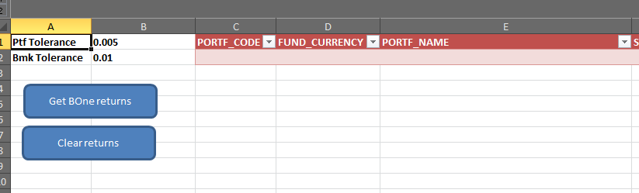

This sheet just collects the returns from B-One. I used a version of the query that is used for the performance process to some columns are not strictly required for FiaT. Details of the query must be looked at against BOne Oracle database. The main idea is that it calculates the Total return based on the NAV screen. It replicates the calculation based that BOne does when calculation the top level return on the Equity Attribution screen.

DTS
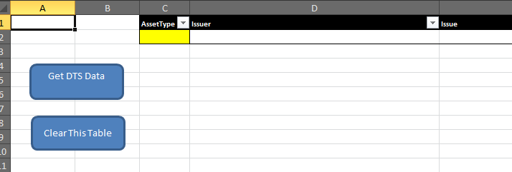
This sheets callas a query in iRIS and collects the DTS data from there. The most important thing to remember here is that the DTS weights are recalculated by FiaT and so it must map correctly the weights using the ticker ID column to B-One Bloomberg Ticker. I designed this mapping as there was nothing else available between the two systems. However, there may still be a better solution. The DTS weighting calculation is done using sumif.

The VBA code for the DTS was written by the Risk team. I have never really changed it much.

BbergData
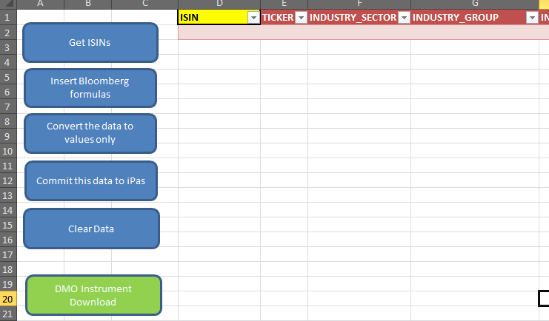
This sheet can collect data from Bloomberg terminal using the typical Bloomberg formulas. In addition, the user can load this data to iPas through a staging table. Bloomberg data has separate table from the rest of the static data as this data should have a good reliability however remember that we have seen Bloomberg changing their static data so they are as accurate a Bloomberg can get it right and as we load it to iPas.

This data are returned from the database using the ISINs from the BOne Export sheet and the query stored with the sheet ‘ISIN_StaticData’. There is query that returns them.

Get ISINs
This executes the query to collect ISINs that have not been previously run thought this process. It shows new instruments. It uses the query a simple left join to collect the relevant ISINs. The ISINs that are not available in the iPas Static Data sheet are new.

Insert Bloomberg formulas
This inserts the relevant formulas. This is a simple code.

Convert the data to values only
No comments

Commit this data to iPas
This uses staging table prf.FiaStagingDataBB and a stored procedure prf.upsLoadDataToFinalTable_FiaDataBB. The final table is prf.FiaDataBB. You can see the data model below.

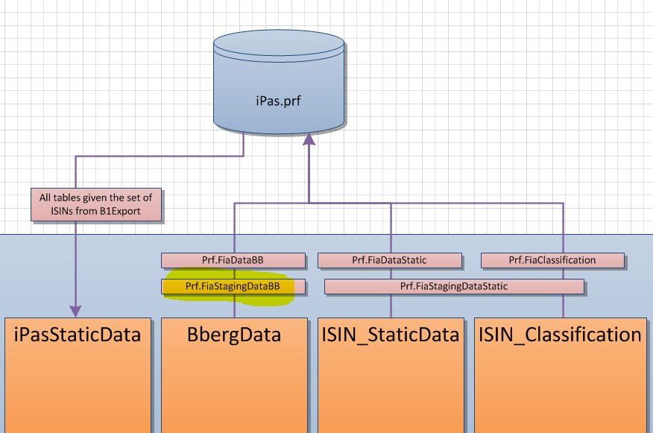

The stored procedure is highlighted below.
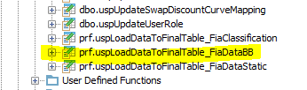

Clear Data
Clear the table

DMO Instrument Download
This creates a bank sheet where the DMO data is temporarily placed. Then the mapping for the Bloomberg load sheet is done via and SQL query that runs against the temporary sheet.

User has an option of review the data before loading.

Please remember that the Incursion connection to DMO’s Phoenix database is not very stable – the query is allowed to last only 2 minutes. If you don’t get any data from the query, you may try to press it multiple times so Phoenix cashes the query results. Then you may get the query results.

iPasStaticData
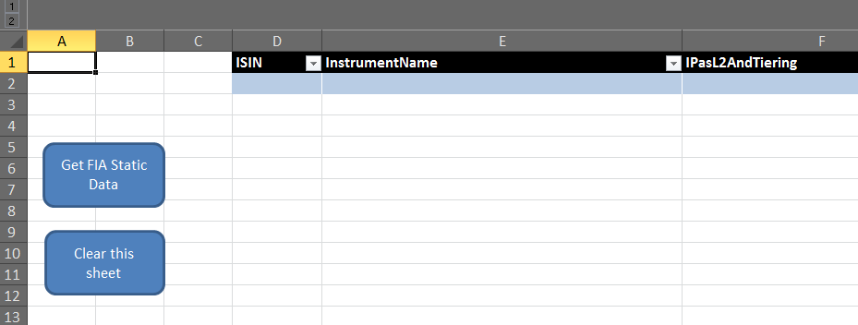
This sheet displays relevant static data (instrument/isin classification, ratings, country of risk and so on). This sheets collects the ISINs from BOne export and uses them as filter (a string in the where clause).

In addition, this sheet feeds the final query that is sent to the final reports.

It handles 4 different classifications that are collected from B-One.

It has many columns and some of them are not used however they may be required. It shows both Bloomberg Data and our static data.

Below is the ERD for the database. The foreign keys are not defined on the database level.

Get FIA Static Data
This does the query as in the below schema. There is only one query to collect all data. It uses ISINs from BOne export to filter the set of instruments to cover by this process.

Clear this Sheet
This is just cleaning code.

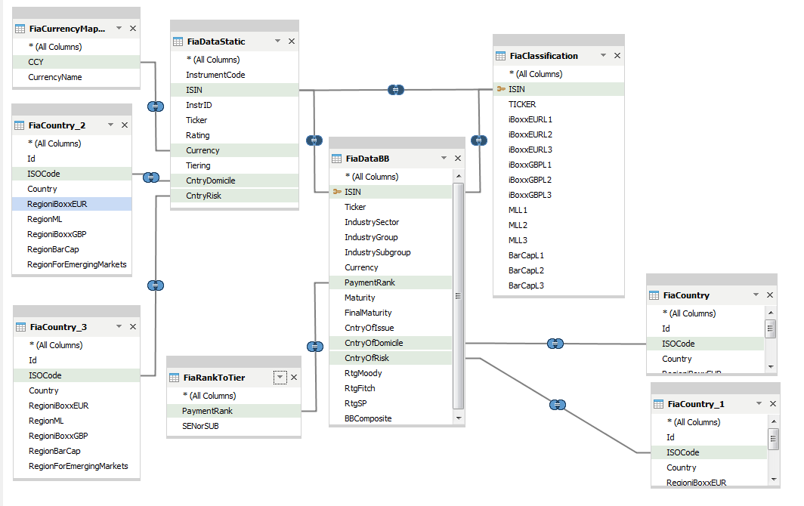

ISIN_StaticData
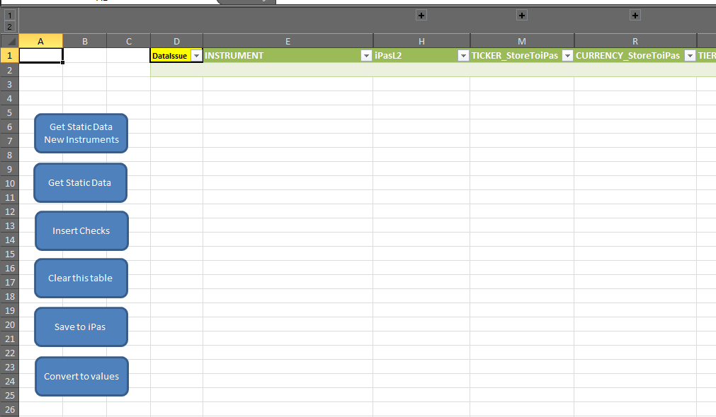
This sheet gives people an option to amend and check data such as Currency, Tiering, Ratings or Country for each ISIN. It does not handle any other instruments than bonds (ISINs).

See it Excel formulas it uses. We try to come up with a way to programmatically pick best choice between these data based on the data source however we have never really been successful in this effort. The team can change the classification manually and save it to the database.

Only the columns that are highlighted in bolds will be load in iPAS.

Get Static Data New Instruments
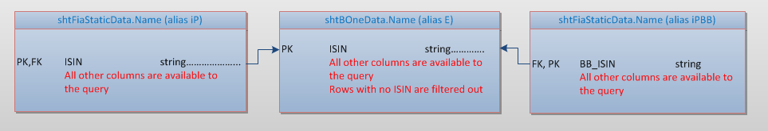

This executes a query against the sheet with BOne data sheet and iPas static data sheet. It prints out only the required columns for instruments with ISIN.

This button prints only results that are missing classification on the iPas static data sheet. Access SQL filters are applied in the query.

Get Static Data

This executes a query against the sheet with BOne data sheet and iPas static data sheet. It prints out only the required columns for instruments with ISIN.

This button prints all results.

Insert Checks
The subroutine inserts formulas in the give table. The formula should help to user to identify problematic classifications.

Clear this table
This clears the table.

Save to iPas
This sub uploads the data to iPas. The target table is prf.FiaStaticData.
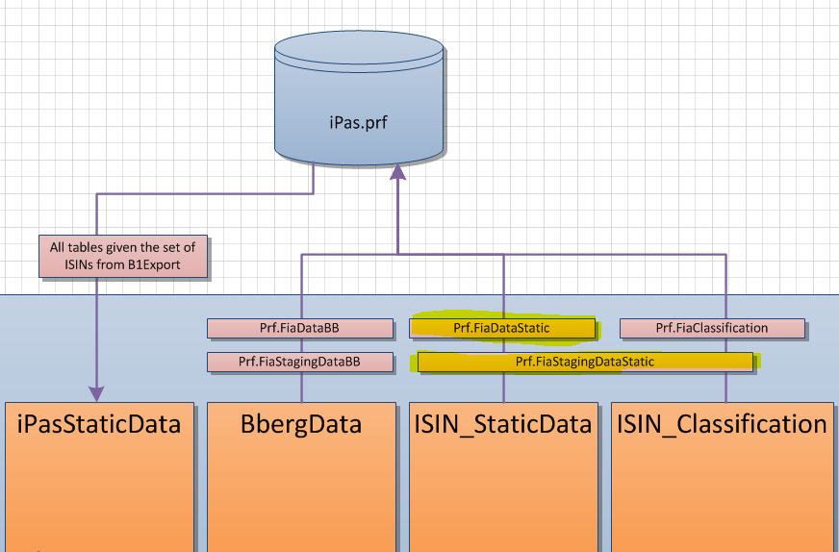

It uses the stored procedure:
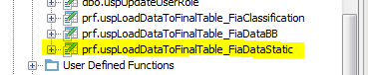

Convert To values
Only the values in the given table are stored as values and nothing else.

ISIN_Classification
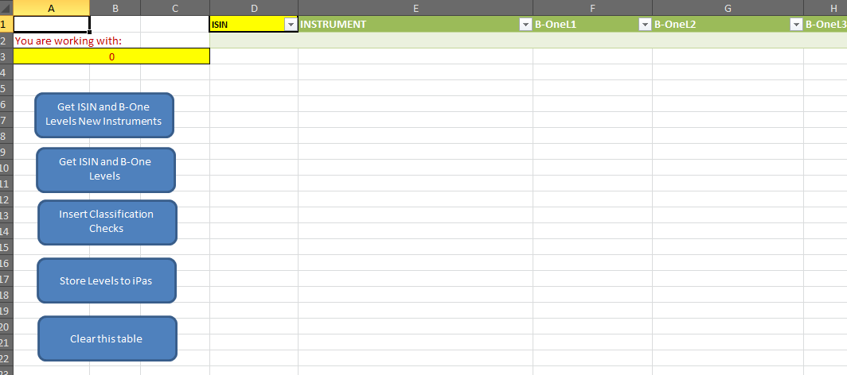

This is works with 5 different classification type for each portfolio.
There are:
FIA - Markit iBoxx GBP Overall
FIA - Markit iBoxx EUR Overall
FIA - Barclays Global
FIA - BofA Merrill Lynch (Level 3)
FIA - BofA Merrill Lynch (Level 4)

Each classification is mapped to iPas level columns in a fixed way. There is not dynamic referencing for this mapping.

The only dynamic aspect is based the the classificaitons. The code uses select statement.

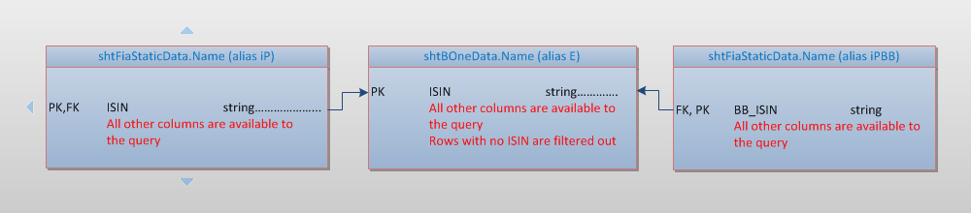

Get ISIN and B-One Levels New Instruments
This uses the query as above. Only the instruments that are missing the classification in IPas data sheet are returns

Get ISIN and B-One levels
This uses the query as above. This returns all instruments with ISIN in the B-One export. The above query is a subset of this one.

Insert Classification Checks
Inserts the formulas for checking the classifications. This is meant to help people to stop mistakes in the classification. It is based on priority logic.

Store Levels to iPas
This is the load procedure for uploading the data to iPas. The target table is prt.FiaClassificaiton.

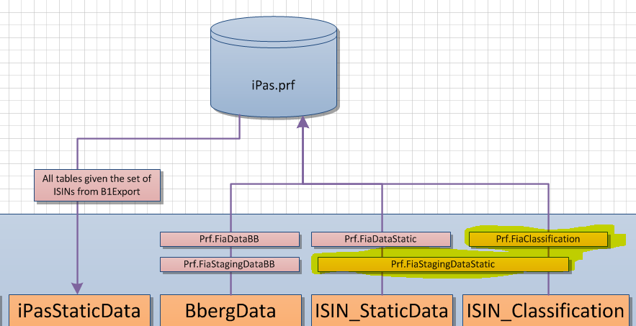

This uses the below stored procedure:
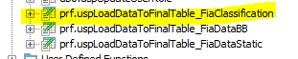

Clear this table
This is just clearing process.

ConfigTables
These tables serve as references for classification. They are grouping all classifications to one classification structure. There a referenced through formulas throughout FIAT.

CDSMapping
This is a query result from B-One. The sheet is created only when the import process finds CDS in the B-One Export. This offers the user a clear view over the CDS code mapping in B-One. Users are expected to use this sheet to map the CDS tickers correctly between B-One BB_ticker field in B-One and DTS data import from the Risk Database.

Reference
This is the same as ConfigTables sheet. It is hidden as users don’t really need. The bank holidays are left there if needed.

User ExcelToOracle API description for connection
To use the instantiate the object:
Add reference for the Coeus project in the ribbon xlam file.
Insatiate the object:

Dim Conn As Coeus.clsDBConn: Set Conn = Coeus.MClassCall.New_clsDBConn

Store the query to string object:

strQry = "SELECT * FROM B1LIVE.PORTFOLIO"

Pass the query to the database caller. Optional argument allows you to print/not print headers. If you pass any string values that is different from the default, the headers are printed.

On Error GoTo errorCatch
sResponse=Conn.strQryDBCall(strQry,”username”,”password”, optional: “NoHeaders”)
On Error GoTo 0

This method prints the query for you.

Conn.ArrayPrint strArray:=sResponse, _
Sheet:=shtBOneData, _
lgStartRow:=shtBOneData.Range("rngBOneDataResults").Row, _
lgStartCol:=shtBOneData.Range("rngBOneDataResults").Column

You can choose to print the values as string only using the methods.

List of the iPas objects used

Tables
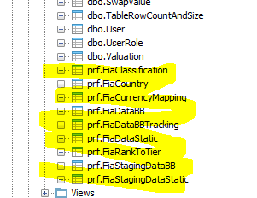

Functions
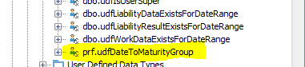

Stored Procedures
